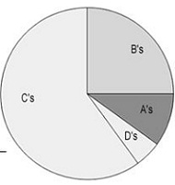**Interpreting Graphs**

1.  Mr. M’s class grades were graphed as a pie graph.  Based on this graph:

a)  The largest percentage of students received what grade?  ________   
b)   Estimate what percentage of the class received a B. ___________  
c)   Estimate what percentage of the class received an A. ___________  
d )  Based on the graph, do you think Mr. M’s class is hard?    
Why or why not?

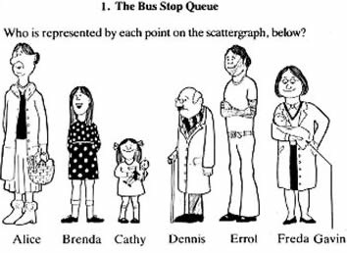

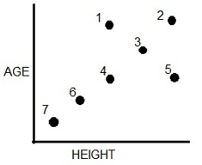

2.  The scatter plot shows a bus stop where those waiting at the bus are plotted by their height and by their age.  Identify which dot goes with which passenger.

1)  _____________________  
2)  _____________________  
3)  _____________________  
4)  _____________________  
5)  _____________________  
6)  _____________________  
7) _____________________

3.  The bar graph compares the number of students enrolled in classes.

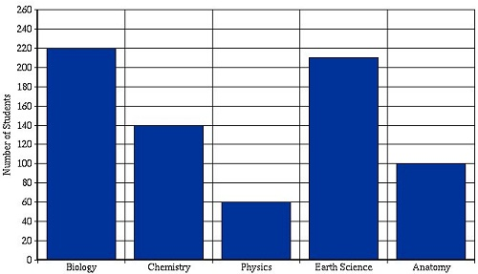

1. What class has the highest enrollment?  
   ______________________________
2. How many students are enrolled in Chemistry?
3. How many are enrolled in Anatomy?
4. Which course is the least popular?

4. This line graph compares the growth of plants that were kept in the sun for different amounts of time.

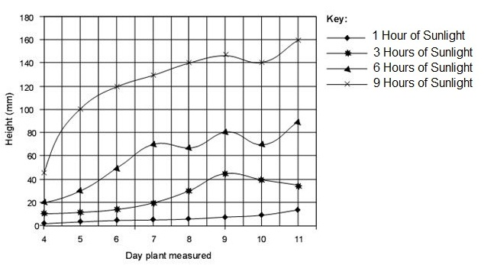a. On day 7, plants kept in the sun for 3 hours were how tall?

b. On Day 7, plants kept in the sun for 6 hours were how tall?

c. On day 10, the plants kept in the sun for 9 hours were how tall?

d. On Day 11, the plant that was grown with 1 hour of sunlight was how tall?

e. Based on the graph, the plant grows best in what amount of sunlight?

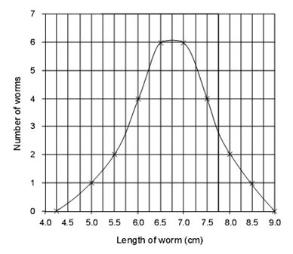5. The line graph shows the number of worms collected and their lengths.

a. What length is most common?

b. What was the longest worm found?

c. How many worms were 6 cm long?

d. How many worms were 725 cm long?

e. The peak curve represents the (longest worm or average worm?)



1. Using the graph answer the following questions:

a. At what point does the paramecium population stop growing?

b. About how many paramecium are there at 5 minutes?



1. Using the graph above answer the following questions:
   1. Approximately how fast does the average elephant run?
   2. Approximately how much faster is the cheetah than the elephant?

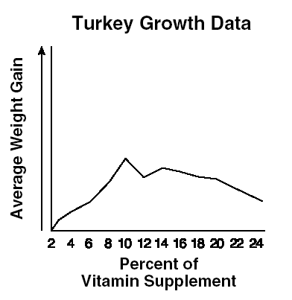

1. Using the line graph
   1. What percent of vitamin supplement gives the heaviest turkeys?
   2. What happens to the weight after that heaviest point?
   3. What does that mean about the amount of vitamins turkeys prefer?