Plant Tissues:
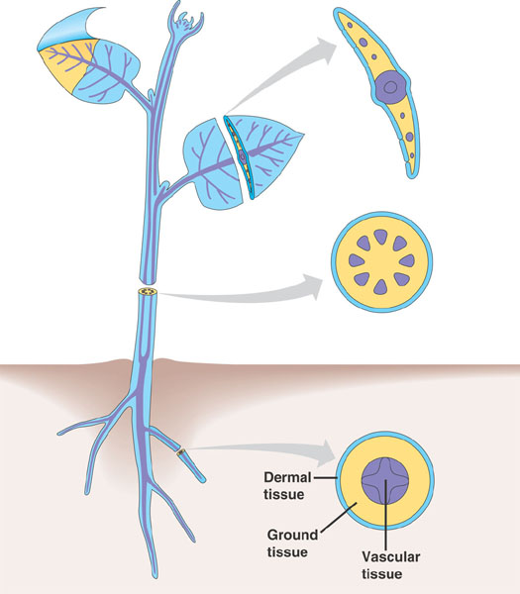
Vascular plants have three tissue systems- the dermal tissue system, vascular tissue system, and ground tissue system.
Fill in the following table:
Characteristics of Plant and Tissue Systems
Tissue System | Location | Function in roots | Function in stems | Function in leaves | Example(s):
Dermal tissue system
Vascular tissue system

Ground tissue system

