Chapter 5 Evolution, Biodiversity, and Population Ecology
Striking gold in Costa Rica
- Golden toads were discovered in 1964, in Monteverde, Chile
- The mountainous cloud forest has a perfect climate for amphibians
- Unfortunately, __________________________________________
- Due to global warming’s drying effect on the forest
Evolution: the source of Earth’s biodiversity
- Biological evolution =
-May be random or directed by natural selection
- Natural Selection =
Understanding evolution is vital
- It alters the genetic makeup of a population
- It is important for understanding antibiotic and pesticide resistance, agricultural issues, production, medicines, etc.

Genetic variation
- Adaptive Trait (Adaptation) =
- Mutations = accidental changes in DNA that may be passed on to the next generation
-Non-lethal mutations provide the genetic variation on which natural selection acts
- Sexual reproduction also leads to variation
Natural selection acts on genetic variation
Directional selection =
Stabilizing selection =
Disruptive selection =
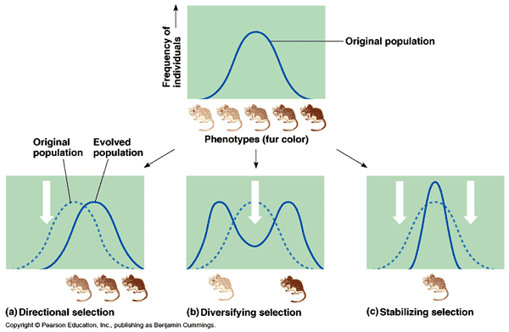
If the environment changes, a trait may no longer be adaptive
Artificial selection
Artificial Selection =
For example, artificial selection has led to the great variety of dog breeds

Evolution generates biodiversity
Biological Diversity =
- The diversity of species
- Their genes
- Their populations
- Their communities
Species =

Population =

Speciation produces new types of organisms
- The process of generating new species
  - A single species can generate multiple species
- Allopatric speciation =
  - Can be separated by glaciers, rivers, mountains
  - The main mode of species creation
Another type of speciation
Sympatric speciation =

- Feed in different areas, mate in different seasons
- Hybridization between two species
- Mutations
Extinction
- Species generally evolve from simple to complex and small to big, but the opposite can occur, and some even disappear
- Extinction =

  - Speciation and extinction affect species numbers
Extinction is a natural process
Extinction is irreversible: once a species is lost, it is lost forever

Some species are more vulnerable to extinction
- Extinction occurs when the environment changes too rapidly for natural selection to keep up
- Endemic species =
  - Very susceptible to extinction
  - These species usually have small populations
- Many other factors also cause extinction
  - Severe weather
  - New species
  - Specialized species

Earth has had several mass extinctions
- Background extinction rate =
- Mass extinction events =
- Humans are causing the sixth mass extinction event

Ecology is studied at several levels
Ecology and evolution are tightly intertwined
- Biosphere =
- Ecosystem = _________________ and the _________________ and forces they interact with
- Community = ________________________ that live in the ______________ area
Organismal ecology: habitat
- Habitat =
  - Includes living and nonliving elements
  - Scale-dependent: from square meters to miles
- Habitat use = each organism thrives in certain habitats, but not in others
- Habitat selection = the process by which organisms actively select habitats in which to live
  - Availability and quality of habitat are crucial to an organism’s well-being
  - ______________________ conflict with this process
Organismal ecology: niche
- Niche = an organism’s _________________________________________________ in a community
  - Habitat use, food selection, role in energy and nutrient flow
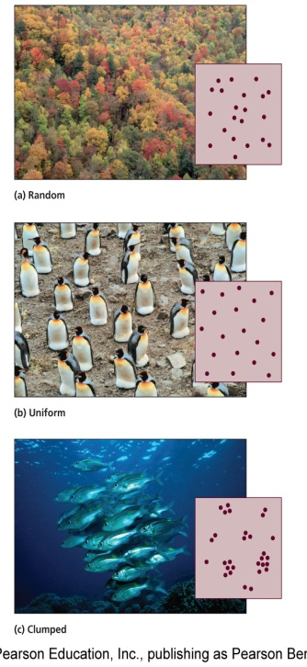
  - Interactions with other individuals
- __________________ = species with narrow niches and very specific requirements
  - Extremely good at what they do, but vulnerable to change
- __________________= species with broad niches that can use a wide array of habitats and resources
  - Able to live in many different places
Population characteristics
- All populations show characteristics that help scientists predict their future dynamics
- Population size =
- Population density =
  - High densities make it easier
Population characteristics
- Population distribution (dispersion) = spatial arrangement of organisms within an area
  - _______________ – haphazardly located individuals, with no pattern
  - _______________– individuals are evenly spaced due to territoriality
  - _______________ – arranged according to availability of resources
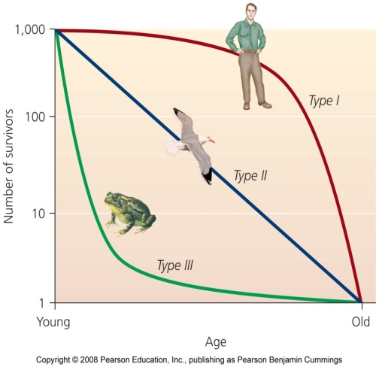
    - Most common in nature
Birth and death rates

- Survivorship curves = the likelihood of death varies with age
- Type I:
- Type II:
- Type III:

Four factors of population change
- _______________ = births within the population
- _______________ = deaths within the population
- _______________= arrival of individuals from outside the population
- _______________ = departure of individuals from the population
Growth rate formula =

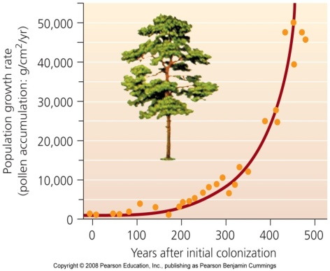
Exponential population growth
- Steady growth rates _____________________ population growth
  - Something increases by a fixed percent
  - Graphed as a _______________ curve
- Exponential growth cannot be sustained indefinitely
  - It occurs in nature with a small population and ideal conditions
Limiting factors restrain growth
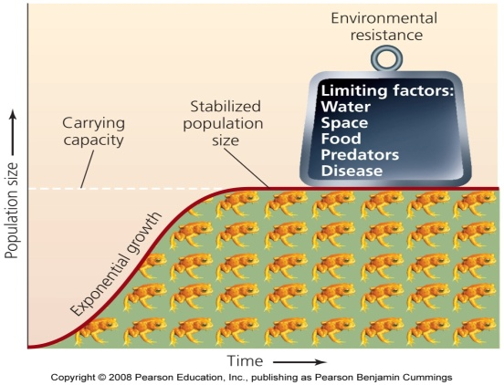
- Limiting factors =

  - Water, space, food, predators, and disease
- Environmental resistance = All limiting factors taken together
Carrying capacity
- Carrying capacity =

  - An S-shaped logistic growth curve
  - Limiting factors slow and stop exponential growth
- Carrying capacity changes
Humans have raised their carrying capacity by decreasing the carrying capacity for other species
Population density affects limiting factors
- ____________________ factors = limiting factors whose influence is affected by population density
  - Increased risk of predation and competition for mates occurs with increased density
- _________________ factors = limiting factors whose influence is not affected by population density
  - Events such as floods, fires, and landslides
Biotic potential and reproductive strategies vary
- Biotic potential =
- ________________________ = animals with long gestation periods and few offspring
  - Have a low biotic potential
  - Stabilize at or near carrying capacity
  - Good competitors
- _____________________ = animals which reproduce quickly
  - Have a high biotic potential
  - Little parental care
