Directions: Answer all parts of the question. Use the diagram of the food web below to answer the following questions.

- List 3 different food chains of different lengths.

- Using a food chain with at least 4 organisms, create an energy pyramid with correct labels (types of consumers, producers, etc).

- Using 1 food chain from above (with 4 organisms), calculate the amount of energy available for each trophic level (see value key)

- Describe the impact the removal of the frog will have on the entire food web.

- Describe the 10% rule of energy transfer in a food web.

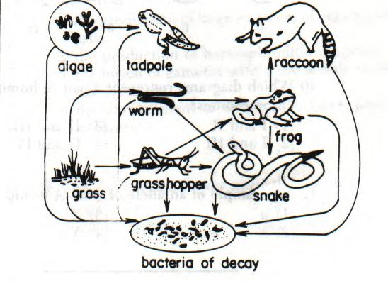
Energy Value Key
Producers – 10,000 kcal/m²/year
Primary Consumers – ?
Secondary Consumers – ?
Tertiary (higher) consumers – ?

