Unit 4: Water
EXAM= A-DAY: 11/14 B-DAY: 11/15
Answer everything in complete sentences

Chapter 15 Questions: A-DAY DUE: 10/29 B-DAY DUE 10/30
- Define freshwater and where it is found.
- Define wetlands and include the 3 types of wetlands.
- Define groundwater.
- What role does groundwater play in the hydrologic cycle?
- Why are sources of fresh water unreliable for some people and plentiful for others?
- Describe three benefits of damming rivers and describe three costs of damming rivers.
- What particular environmental, health, and social concerns has China’s Three Gorges Dam and its reservoir raised?
- Why do the Colorado, Rio Grande, Nile, and Yellow Rivers now slow to a trickle or run dry before reaching their deltas?
- Why are the water tables dropping around the world?
- What are some environmental costs of falling water tables?
- Describe 2 ways in which we can lessen agricultural demand for water.
- Describe 2 ways in which we can reduce household water use.
- Name three major types of water pollutants, and provide an example of each.
- List three properties of water that scientists use to determine water quality.
- Why do many scientists consider groundwater pollution a greater problem than surface water pollution?
- What are some anthropogenic (human) sources of groundwater pollution?
- Briefly describe how drinking water is treated.
- How does a septic system work?
- Describe and explain the major steps in the process of wastewater treatment.
- How can artificial wetlands aid such treatment?

FRQ 1: A-DAY DUE 11/4 B-DAY DUE 11/5
Read the Freemont Examiner article below and answer the questions that follow.
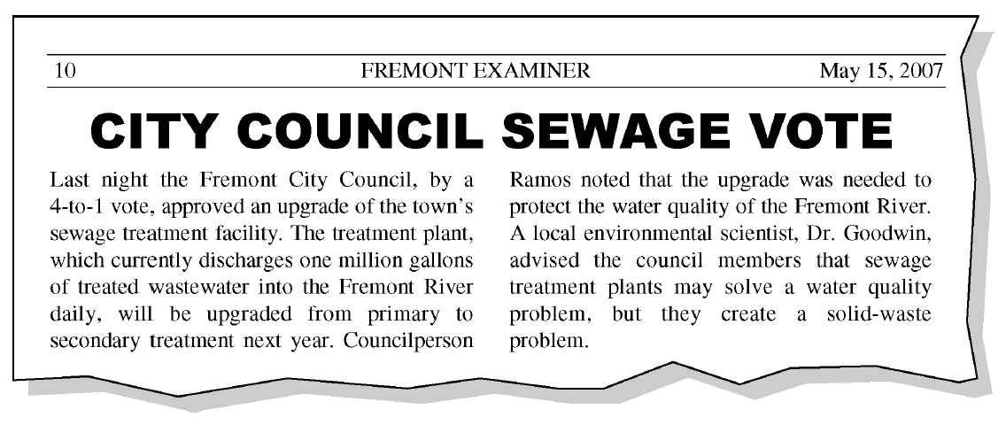
- Identify ONE component of the sewage that is targeted for removal by primary treatment and ONE component of the sewage that is targeted for removal by secondary treatment.

- For EACH of the pollutants that you identified in part (a), describe how the pollutant is removed in the treatment process.

- Explain how sewage treatment plants create the solid waste problem that Dr. Goodwin mentioned in the article.

- Two common methods of disposing of solid waste from sewage treatment plants are transporting it to a landfill or spreading it onto agricultural lands. Describe an environmental problem associated with EACH of these methods.

- The final step in sewage treatment is disinfection. Identify ONE pollutant that is targeted during disinfection and identify ONE commonly used method of disinfection.

- Identify ONE United States federal law that requires monitoring the quality of the treated sewage that is discharged into the Fremont River.

Chapter 16 Questions: A-DAY DUE: 11/8 B –DAY DUE 11/11
- What proportion of Earth’s surface do oceans cover?
- What is the average salinity of ocean water?
- How are density, salinity, and temperature related in each layer of ocean water?
- What factors drive the system of ocean currents?
- In what ways do these movements affect conditions for life in the oceans?
- Where in the oceans are productive areas of biological activity likely to be found?
- Describe three kinds of ecosystems found near coastal areas and the kinds of life they support.
- Why are coral reefs biologically valuable? How are they being degraded by human impact?
- What are tides and what are they caused by?
- What is causing the disappearance of mangrove forests and salt marshes?
- What are estuaries? What is an example? How has it been affected?
- Discuss three ways in which people are combating pollution in the oceans and on our coasts.
- Describe an example of how overfishing can lead to ecological damage and fishery collapse.
- What does the statement “We are fishing down the food chain” mean?
- Explain the conclusion of the Myers and Worm study of 2003. (See figure 16.24.)
- Name three industrial fishing practices, and explain how they create by-catch and harm marine life.
- How does a marine reserve differ from a marine protected area?
- Why do many fishers oppose marine reserves?
- Explain why many scientists say no-take reserves will be good for fishers.
- What ocean regions do you think it would be particularly appropriate to establish as marine reserves? Why?

FRQ 2: A-DAY DUE 11/12 B-DAY DUE 11/13
Coral reefs are produced when corals acquire calcium ions (Ca²⁺) and carbonate ions (CO₃ ²⁻) from seawater and deposit solid CaCO₃ to form their exoskeletons. Scientists are concerned that relatively rapid decreases in ocean water pH will hinder the deposition of CaCO₃. The graph above shows the amount of CO₂ dissolved in ocean water and ocean water pH (shown in parentheses) since 1850 and the predicted changes through 2100.

- Explain how an increase in the amount of dissolved CO₂ in ocean water results in a decrease in the pH of ocean water.

- Explain why the movement of carbon into the ocean has been increasing since 1850.

- In order to model the effects of ocean acidification on coral reefs, some simplifying assumptions can be made. Use the assumptions in the table below to perform the calculations that follow.

Assume that the total global area of corals growing in reefs is 2.5 × 10¹¹ m².
Assume that corals grow only vertically and that the average vertical growth rate of corals is 3 mm/year or 3× 10³ m/year
Assume that the average density of CaCO₃ in corals is 2 × 10³ kg/m³.

- Calculate the current annual global increase in volume, in m³, of CaCO₃ in coral reefs. Show all steps in your calculation.

- Calculate the current annual global increase in mass, in kg, of CaCO₃ in coral reefs. Show all steps in your calculation.

- Because of ocean acidification, it is expected that in 2050 the mass of CaCO₃ deposited annually in coral reefs will be 20 percent less than is deposited currently. Calculate how much less CaCO₃, in kg, is expected to be deposited in 2050 than would be deposited if ocean water pH were to remain at its current value.

- Identify and describe one likely negative environmental impact of the loss of coral reefs.

- Identify one environmental problem (other than one due to ocean acidification or loss of coral reefs) that affects marine ecosystems on a global scale.

