Name: ______________________________
Unit 6 Genetics Study Guide:
Use this study guide to prepare for your Genetics Test
Meiosis
- What is it?
- What happens during it?
- What does it make? And why?
- What is independent assortment? Give an example.
- What is crossing over?
Punnett Squares:
Monohybrid Complete Dominance:
- In humans, the allele for albinism is recessive to the allele for normal skin pigmentation. Cross two heterozygote parents.

  - What is the chance that a child of theirs will have normal skin pigmentation?

  - What is the chance that a child of theirs will be albino?

  - If the child is normal, what is the chance that it will be a carrier (heterozygous) for the albino allele?

- In purple people eaters, one-horn is dominant and no-horn is recessive. Show the cross of a purple people eater that is heterozygous for horns with a purple people eater that does not have horns. Identify the genotypes and phenotypes of their offspring.

- In humans, the brown eye allele is dominant to the blue eye allele. If a homozygous dominant brown eyed male crosses with a homozygous recessive female, what will be the genotypes and phenotypes of their offspring?

DiHybrid Complete Dominance:
In robins, singing lovely is dominant to singing badly. Having a large beak is also dominant to a small beak. A heterozygous singing robin that has a small beak is crossed with a heterozygous singing robin that is also heterozygous for beak size. What is the chance of having a small beak/good singing bird?

Incomplete Dominance:
- When breeding horses, white horses (WW) are bred with chestnut (BB) and they produce palomino horses (BW). Identify the genotypes and phenotypes of the possible offspring when a palomino horse is crossed with another palomino horse.

Co-Dominance /Multiple Alleles:
- A man with type AB blood marries a woman with type B blood. Her mother has type O blood. List the expected phenotypes of their children.

- A father of a child has type AB blood. The mother has type A. Which blood type(s) can their children NOT have?

Probability Practice:
- What is the probability of each of the following sets of parents producing the given genotypes in their offspring?
Parent Genotypes | Offspring Genotypes | Probability
AaBb x AABB | AABB
AaBb x AaBb | AaBb
Aa x aa | Aa

Sex-Linked:
- Colorblindness is an X-linked disorder. If a female is a carrier for colorblindness crosses with a male that is colorblind, what are the possible genotypes and phenotypes of their children?

Pedigrees:

The following pedigree shows the relationship for 4 generations of people. The trait being followed is a genetic disorder that leads to the inability to pay attention in science class (the zzz gene).
- Is the inheritance pattern for the zzz gene dominant or recessive? Explain your reasoning.
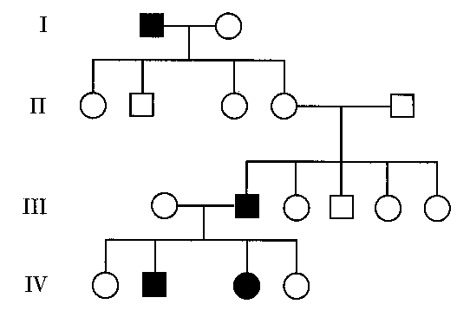

- Use the capital letter "Z" for the dominant allele and lower case "z" for the recessive allele, determine what is the genotype for individual II-4, II-5 and III-1? Justify your answer.

- How can you tell if the trait in a pedigree is sex linked?

Karyotypes:
- What is a karyotype?
- How many autosomes do humans have?
- How many sex chromosomes do humans have? What are they for a male? What are they for a female?
- How many total chromosomes do humans have?
- How can you tell if someone has a disorder or not with a karyotype?
- What disorder is caused by trisomy or an extra 21?
- What disorder is caused by XXY?

